

00000000000000000000000000

About Hitek Water Solutions LTD

HITEK WATER SOLUTIONS LTD is a specialist in water treatment technologies and associated services for drinking water, process water, swimming pool water, domestic water, technical water, hotel and catering water and specific applications.

The company cooperates with the biggest multinationals in the field of water treatment for the development and realization of its own products.

Our Mission

To be a World Leader in the Water treatment Industry by providing solutions to every water problem presented to us.

Location

We are located at Kanjokya House – Kanjokya Street P lot 90/92, Kamwokya Kampala.

Our Work

Our products are completely made in Italy; each component is designed, realized and assembled in Italy according to the most recent law. Each product before entering the market is certified according to the most high standards of safety & quality (TUV, NSF).

With more than 30 years of experience, we understand our customers and can provide the best solutions for your water treatment needs since at Hitek Water Solutions LTD, customer satisfaction is our primary objective. .

Thanks to our many prime partners that include;

Suez Distributors – RO membranes, NF & UF, filters Ozone.

Pentair Distributors – Siata, Fleck, Structural, Code line pressure vessels

DuPont Official Distributor for Italy and the Mediterranean (RO membranes, NF&UF, Ion exchange resins, ED).

The big investment in innovation technology makes Hitek products the best on the market for reliability& efficiency.

**Technologies**. Reverse Osmosis, micro & Ultra filtration, UV, Softeners are all available. We have attached clear illustrations of the chemicals and electronic devices since this can help in making life simpler.

HITEKS European research centres located in Italy continually develop and optimize new procedures; filtration, membranes, ion exchange and disinfection systems.

Thanks to our extensive investment in innovation since at Hitek Water Solutions LTD we offer the latest innovative solutions that you need, as soon as they come out on the market.

At Hitek Water Solutions, we offer the best possible solutions in terms of technology, design and reliability with certification in UNI EN ISO 9001:2008,

UNI EN ISO 14001:2008 & UNI EN ISO 1014:2008.

Our Clients (over one million satisfied customers worldwide annually)

* Beverage and Brewery industries (illustrations )
* Oil & Petroleum (illustations)
* Pharmaceuticals (illustrations )
* Steel and Aluminium (illustrations)
* Homes and Hotels (illustrations )

Our partners

C:\Users\GIVA\Desktop\EUNICE\nav-logo-main-1.pngC:\Users\GIVA\Desktop\EUNICE\suez-logo.png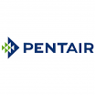

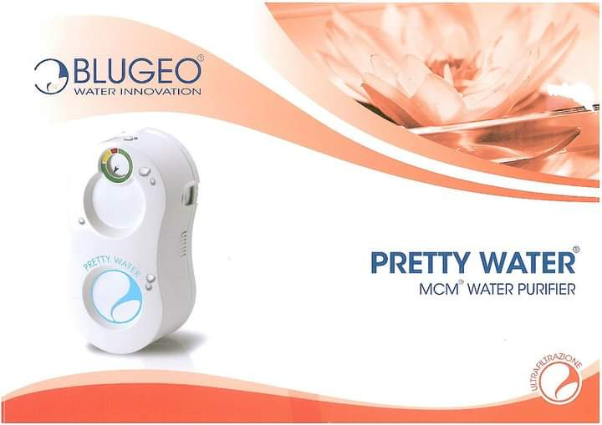

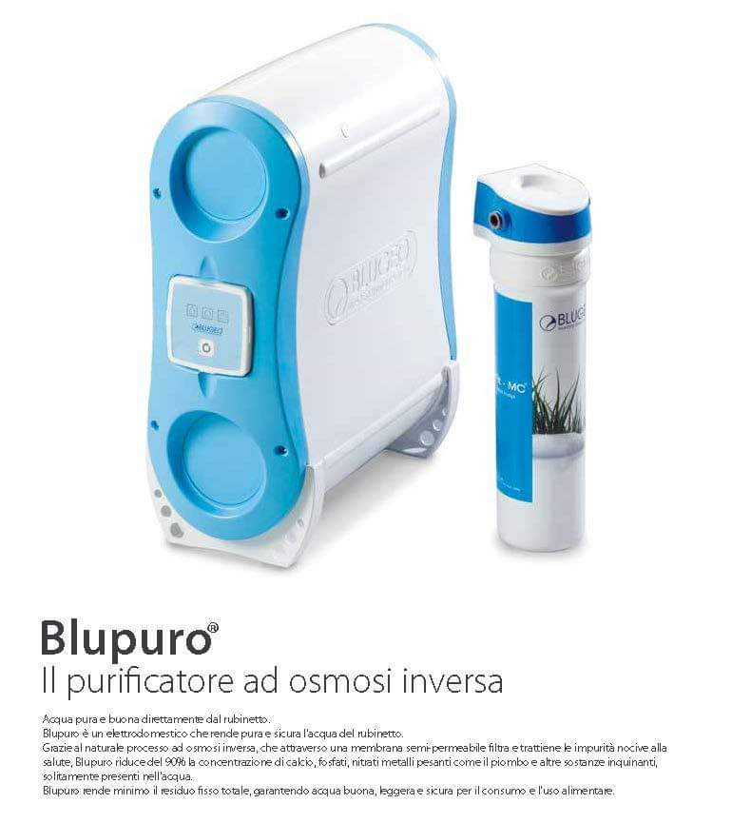**Pretty Water . Easy to install and easy to use** 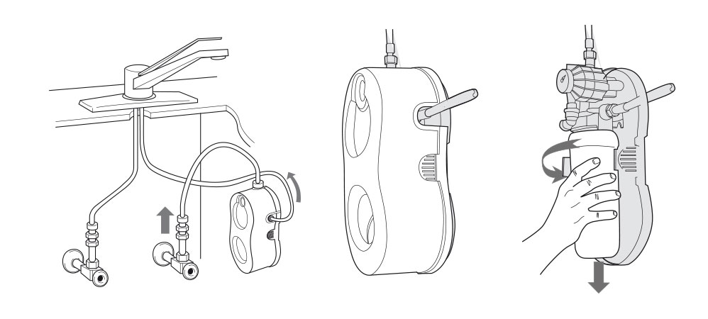

Pretty water is distinguished for its compact dimensions and elegant design; is comfortably adaptable under the sink and integrates perfectly within the kitchen environment.

Simple and easy to install and maintenance, Pretty water is completely automatic, without the need for electricity. Thanks to the bayonet system the replacement of the cartridge is very quickly.

**Pretty water Micromolecular filtration MCM**

Pretty Water is an appliance that makes tap water bacteriologically clean and pure . Thanks to the innovative process of Micro molecular filtering , a physiological barrier of fibres that stop dangerous and unhealthy impurities is created .

Pretty water drastically reduces the chlorine concentration , bad taste and smell and removes the suspended solids normally present in water ,being therefore able to guarantee water that is both bacteriologically pure and safe for alimentary use

